**PART 1 - Work Item Breakdown**

**1. Create Epics**

Example Epics:

User Management

Account Services

Fund Transfer

Transaction History

Security & Compliance

**2. Under Each Epic, Create Features**

Example for 'User Management' Epic:

User Registration

User Authentication

Password Reset

**3. Break Features into User Stories**

Example for 'User Registration' Feature:

As a new user, I want to register using email and password.

As an admin, I want to approve user registrations (Optional).

**4. Break User Stories into Tasks**

Example Tasks for Registration User Story:

Design registration form (Frontend)

Create API for registration (Backend)

Add user details to database

Validate user inputs

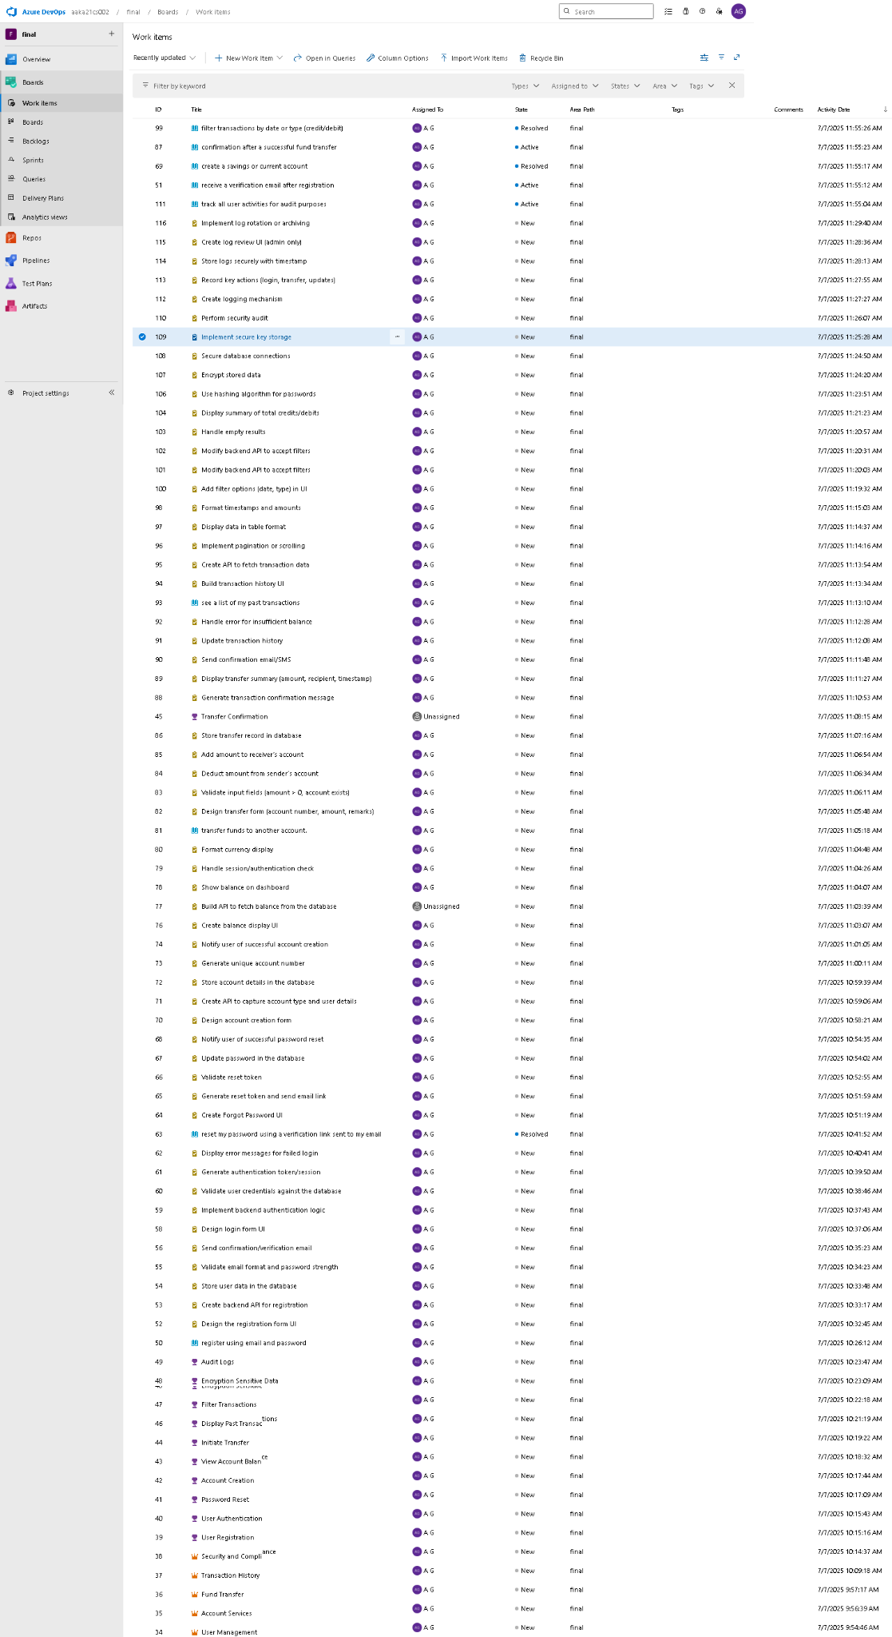

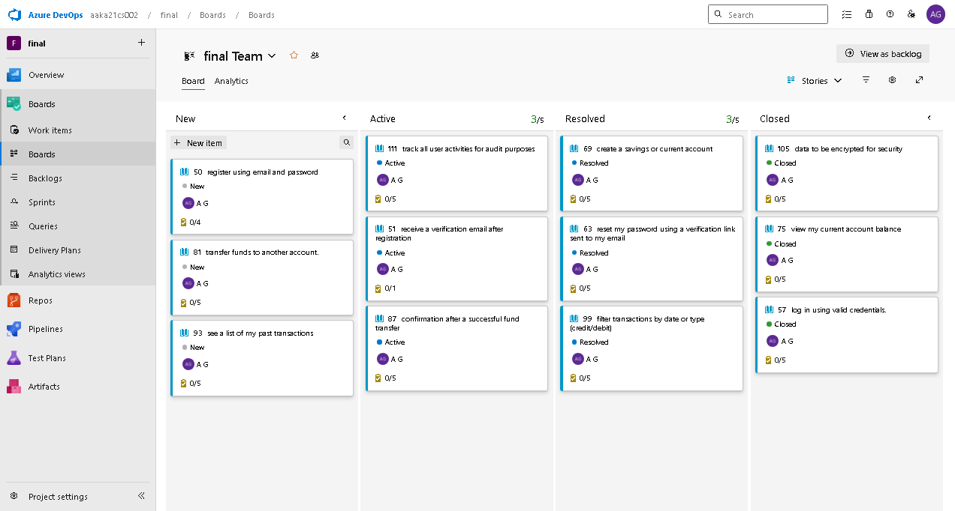

Boards

**PART 2 - Azure DevOps Git Setup**

**1. Create a Git Repo**

Azure DevOps → Repos → New Repository → Name it banking-app

Clone repo locally or use portal

Add a basic project structure:

banking-app/

├── README.md

├── src/

│ └── app.py # Placeholder Python file

└── .azure-pipelines.yml

app.py can simply contain:

print("Banking Application Placeholder")

**ya.yaml (azure-pipelines.yml)**

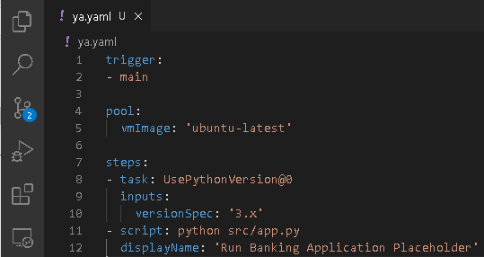

**app.py**

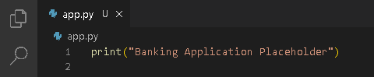

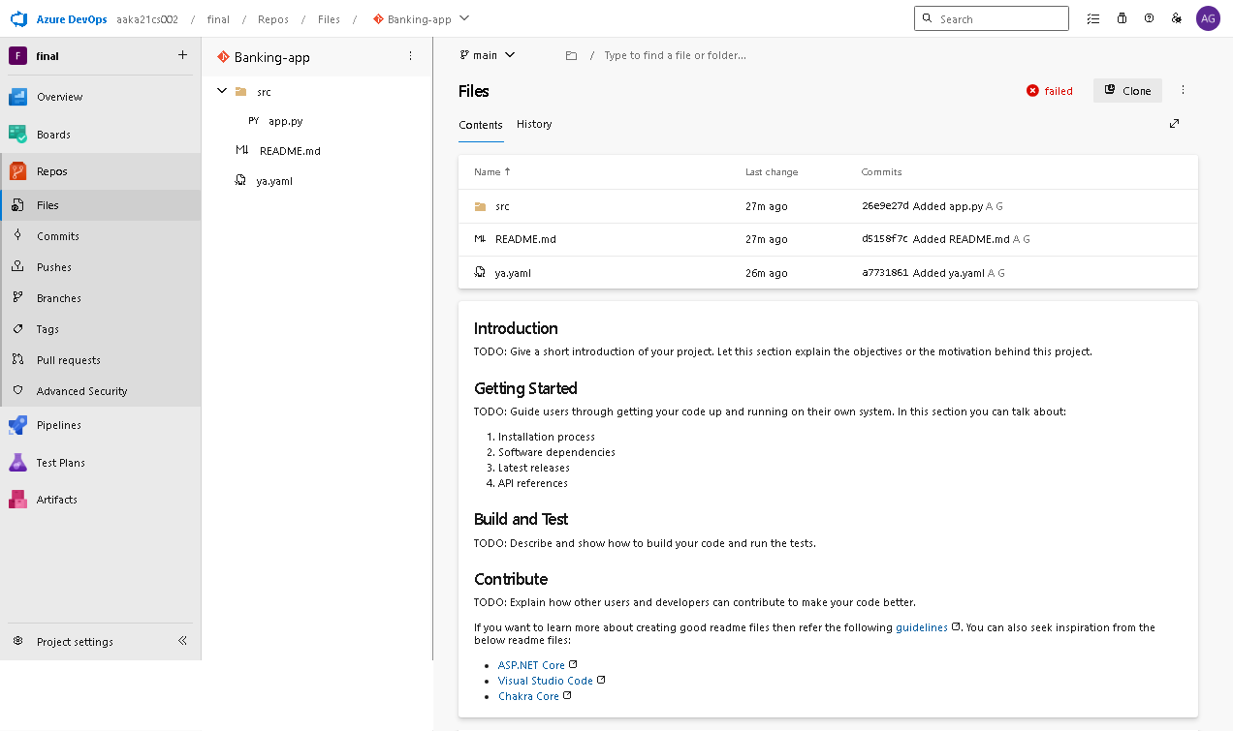

**Azure devops repo (Files)**

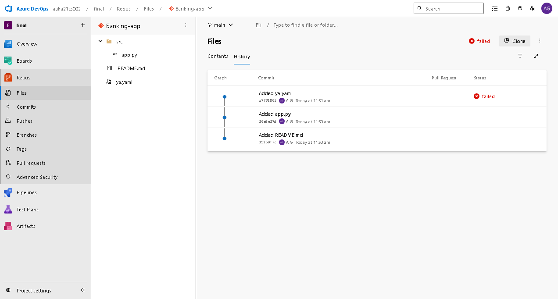

**Azure devops repo (Files)**

**PART 3 - Configure CI/CD Pipeline**

**1. Create Simple Pipeline**

Example .azure-pipelines.yml :

trigger:

- main

pool:

vmImage: 'ubuntu-latest'

steps:

- task: UsePythonVersion@0

inputs:

versionSpec: '3.x'

- script: python src/app.py

displayName: 'Run Banking Application Placeholder'

Pipeline succeeds if the script runs without errors.

**ya.yaml (azure-pipelines.yml)**



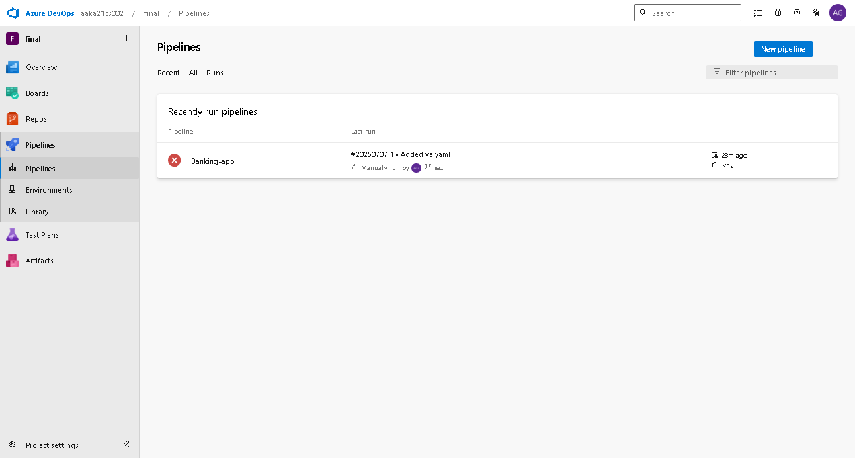

**Azure devops pipelines**

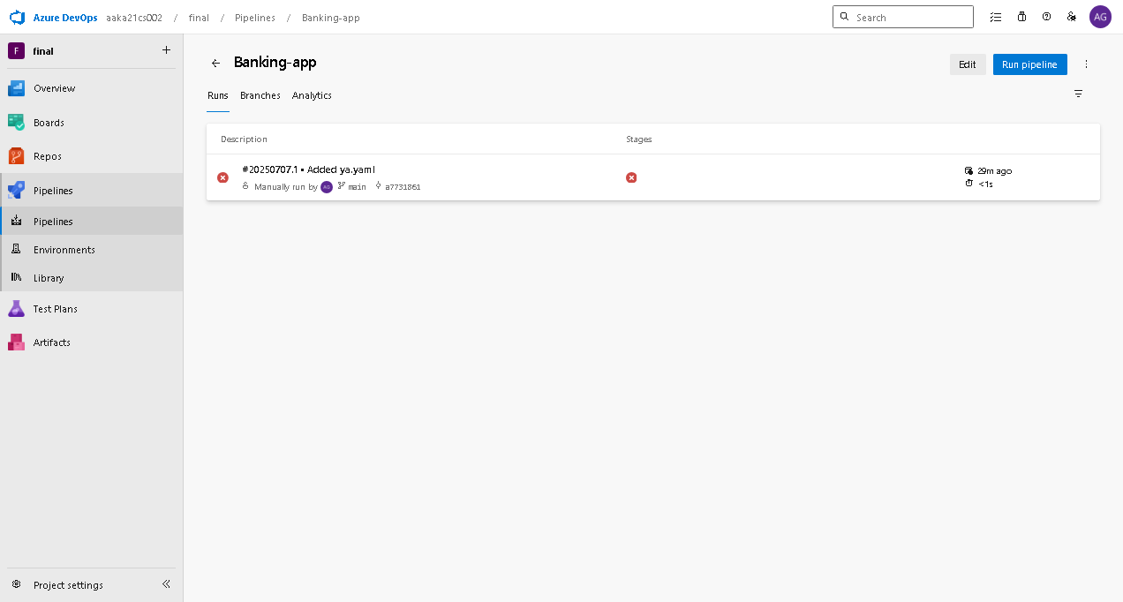

**Azure devops pipeline runs**

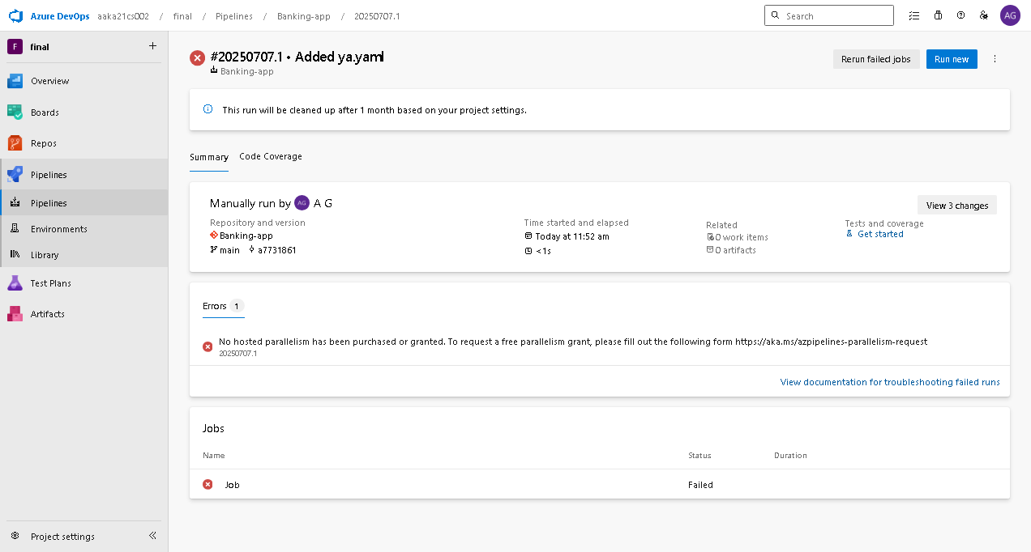

**Azure devops pipeline run details**